**Installation Prerequisites**

## **HP TechPulse**

## **Pre-requisites:**

* To download the ‘HP TechPulse file follow the below steps:
* 1. Download the HP TechPulse file from the below URL.
* 2.File: HP TechPulse_setup.exe
* 3.URL: <https://www.hpdaas.com/software>

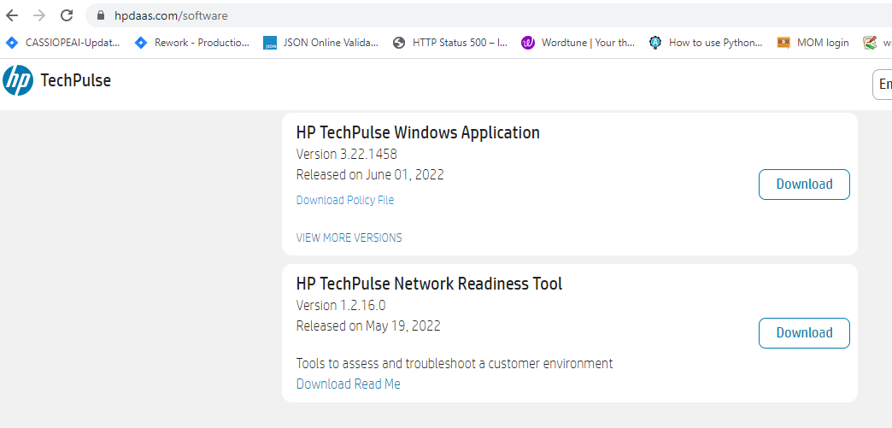

* 4.User should have Administrator right to install software
* Follow the below steps to copy HP TechPulse_setup.exe setup file into the specific directory. (Eg. C:\Share\TechPulse\)
* 1. Log in to the machine where HP TechPulse will be installed.
* 2. Go to the location where ' HP TechPulse_setup.exe' setup file is downloaded.
* 3. Copy the ' HP TechPulse_setup.exe' setup file.
* 4. Navigate to the specific directory where 'HP TechPulse_setup.exe' will be copied. (C:\Share\TechPulse)
* 5. Paste the copied 'HP TechPulse_setup.exe' setup 'file.

## **Installation:**

* + - Log in to the machine where HP TechPulse will be installed.
    - Navigate to the directory where the 'HP TechPulse_setup.exe' file is copied.
    - Double click on 'HP TechPulse_setup.exe'. After that 'Welcome to HP HP TechPulse' windows will be opened.

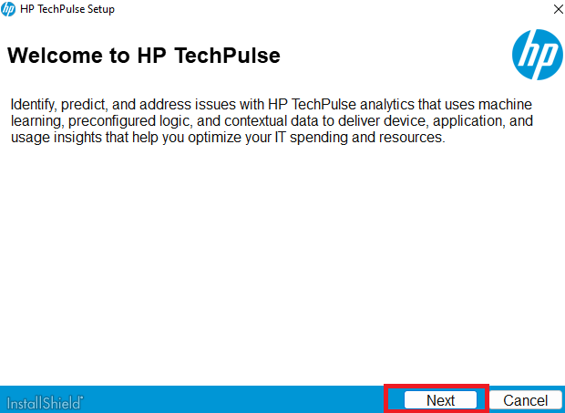

Fig:1 Welcome To HP TechPulse

* + - Click on 'Next' Button. After that 'License Agreement' windows will be opened.

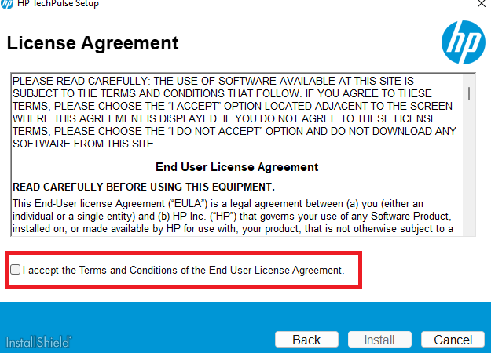

Fig:2 License Agreement

* + - Click on 'I accept the terms and conditions of the End User License Agreement' button.

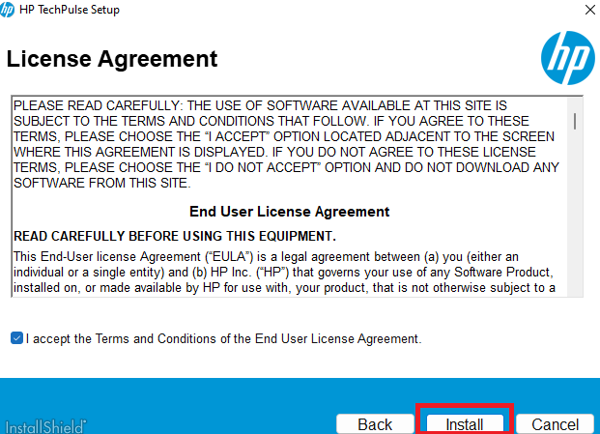

Fig:3 I accept the terms and conditions of the End User License Agreement

* + - Click on 'Install' Button. After that 'Installation Complete' windows will be opened

## **Verification:**

* Open 'Control Panel'.
* Navigate to 'Programs\Programs and Features'.
* ‘Local Administrator Password Solution’ must be present in the installed software list.

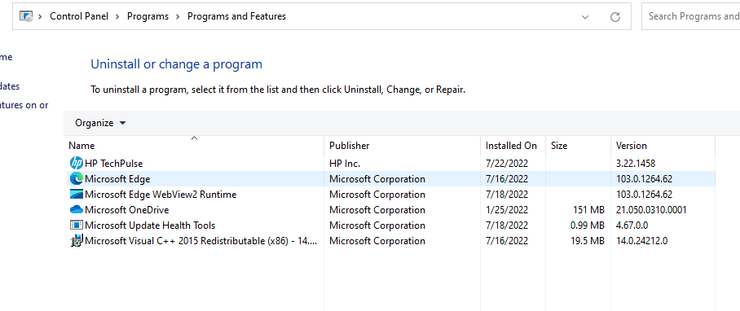

Fig4: Verification of Installation